**AWS Task-2**

Set up a VPC with an Internet gateway, create a public subnet with 256 IP addresses, a private subnet with 256 IP addresses, make a route table connecting the Internet gateway and the subnets, and launch a Linux EC2 instance by using the above VPC and public subnet.

**1. **Set up a VPC****

· Open the **VPC Dashboard** in AWS.

· Click **Create VPC**.

· Select **VPC only**.

· Enter the details **Name**: VPC-01 and **IPv4 CIDR block**: 10.0.0.0/16 (to accommodate subnets with /24 CIDR blocks).

· Click **Create VPC**.

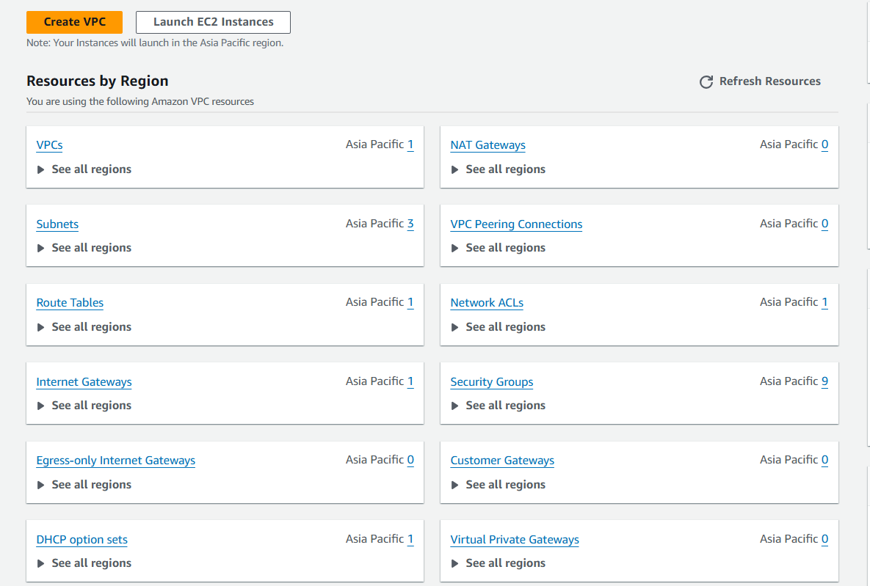

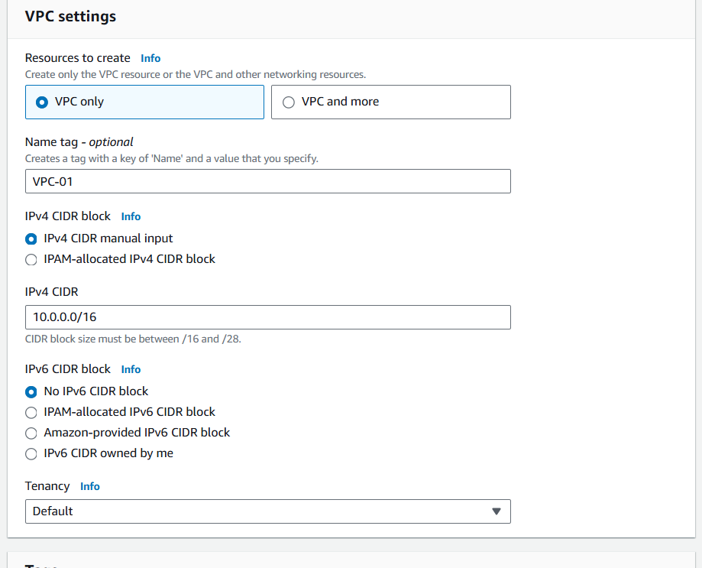

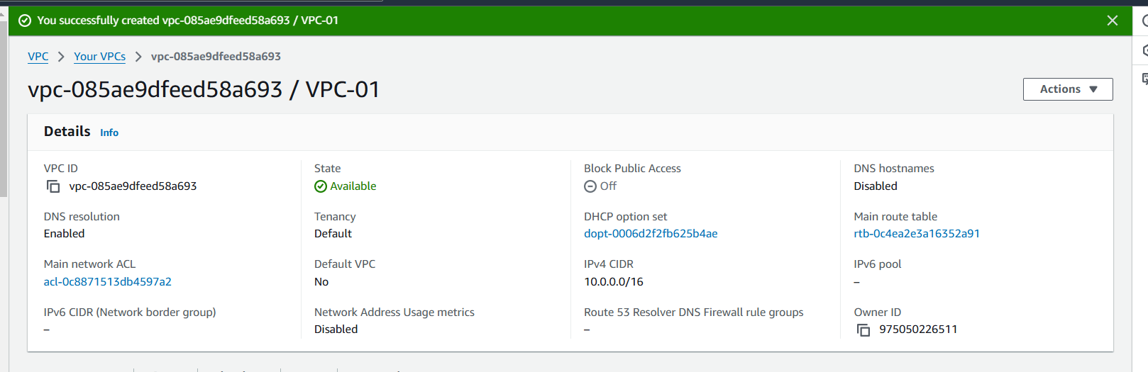

### 2. ****Create an Internet Gateway****

* In the **VPC Dashboard**, go to **Internet Gateways**.
* Click **Create Internet Gateway**.
* Enter a name: My-IGW.
* Click **Create Internet Gateway**.
* Attach the Internet Gateway to your VPC:
* Select the created Internet Gateway.
* Click **Actions > Attach to VPC**.
* Select VPC-01 and confirm.

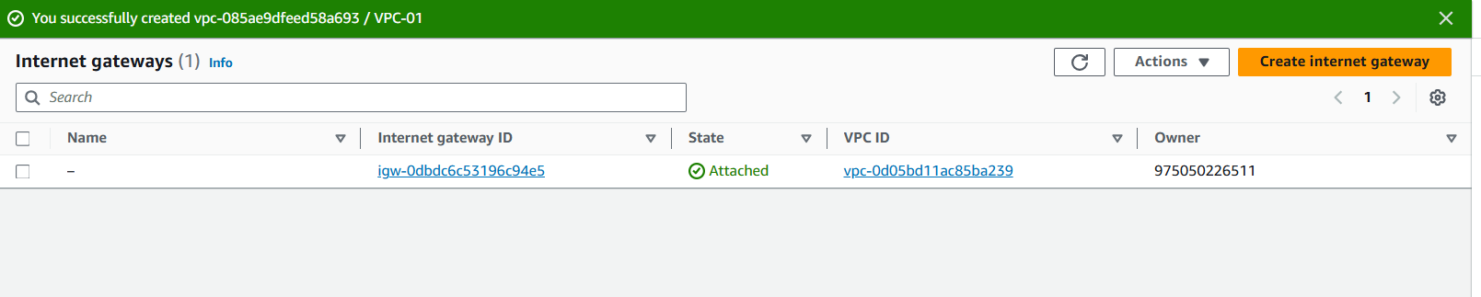

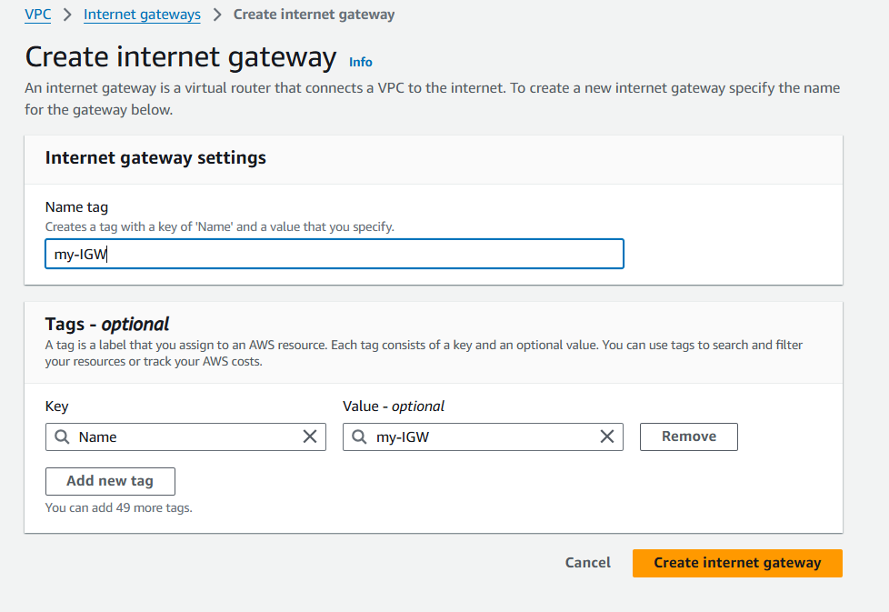

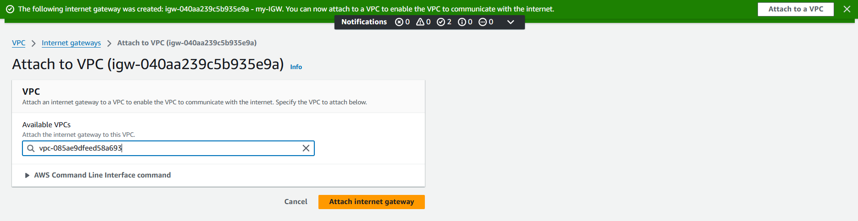

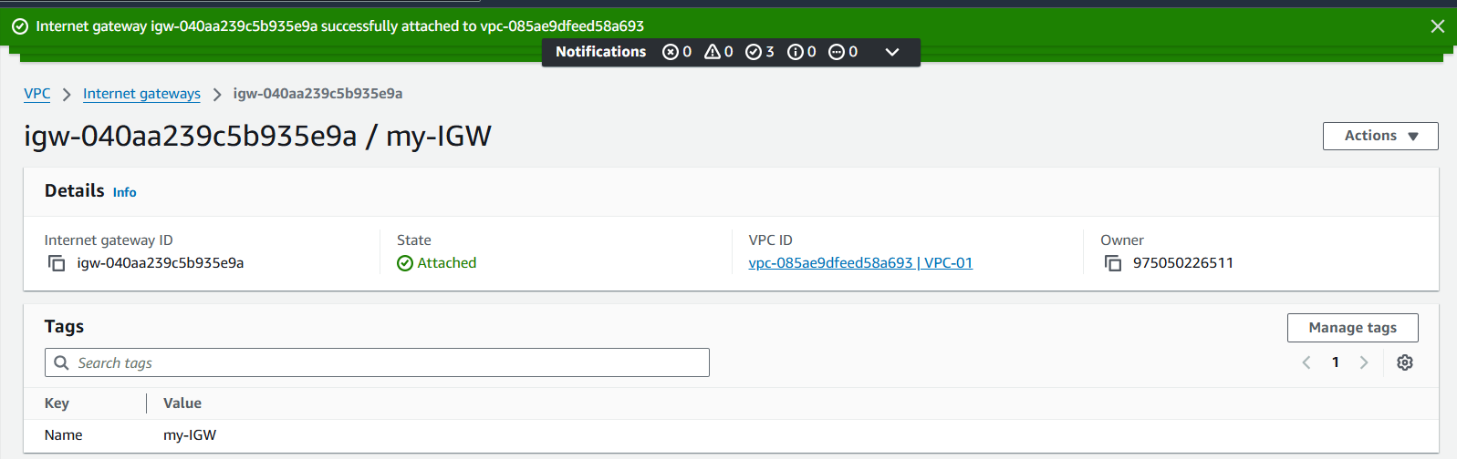

### 3. ****Create a Public Subnet****

* In the **VPC Dashboard**, go to **Subnets**.
* Click **Create Subnet**.
* Enter the details:
* **Name**: PublicSubnet.
* **VPC**: Select MyVPC-01.
* **Availability Zone**: Choose one (e.g., ap-south-1a).
* **IPv4 CIDR block**: 10.0.0.0/24 (256 IPs).
* Click **Create Subnet**.
* Enable auto-assign public IPs:
* Select PublicSubnet.
* Click **Actions > Modify auto-assign IP settings**.
* Check **Auto-assign IPv4**.
* 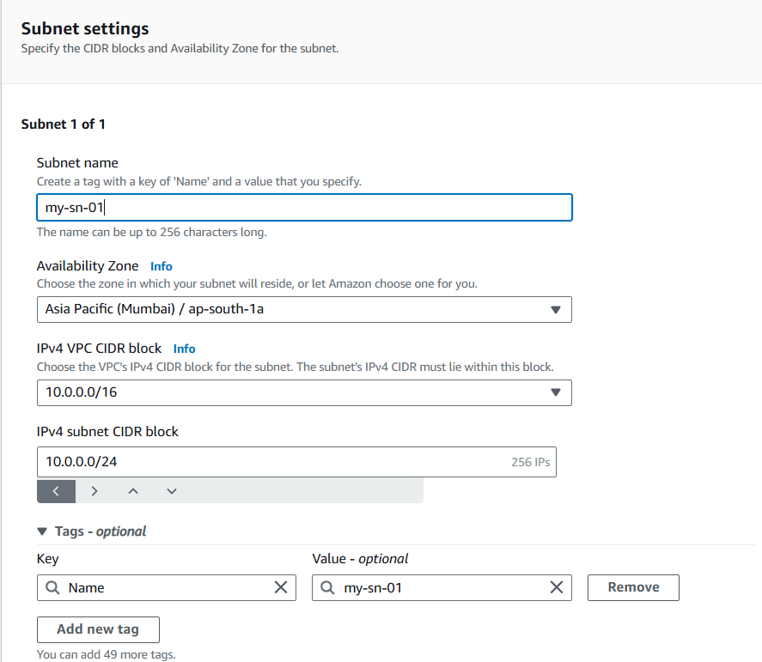

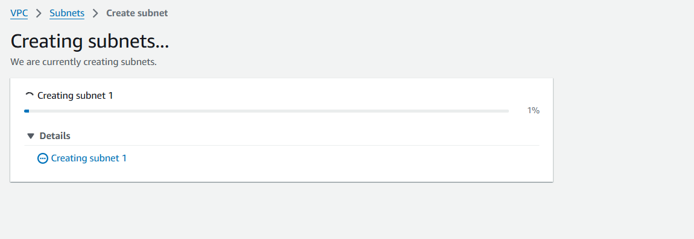

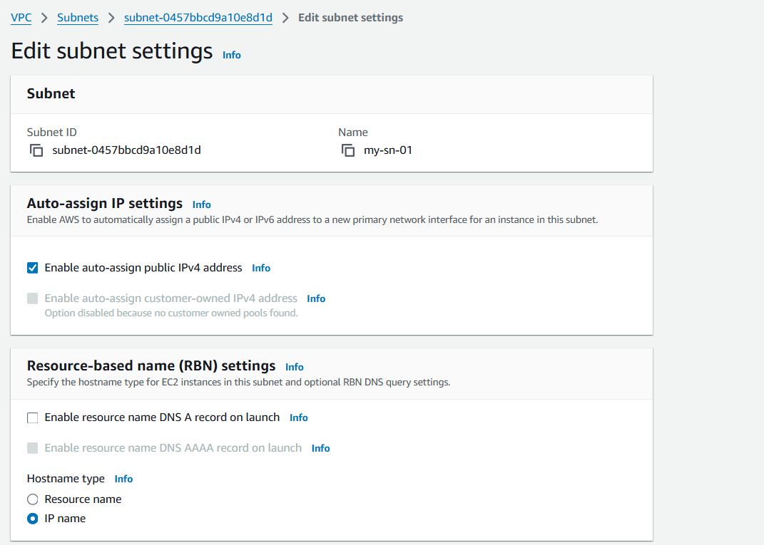

### 4. ****Create a Private Subnet****

* Go to **Subnets** and click **Create Subnet**.
* Enter the details:
* **Name**: PrivateSubnet.
* **VPC**: Select MyVPC-01.
* **Availability Zone**: Choose the same or different from the public subnet.
* **IPv4 CIDR block**: 10.0.1.0/24 (256 IPs).
* Click **Create Subnet**.

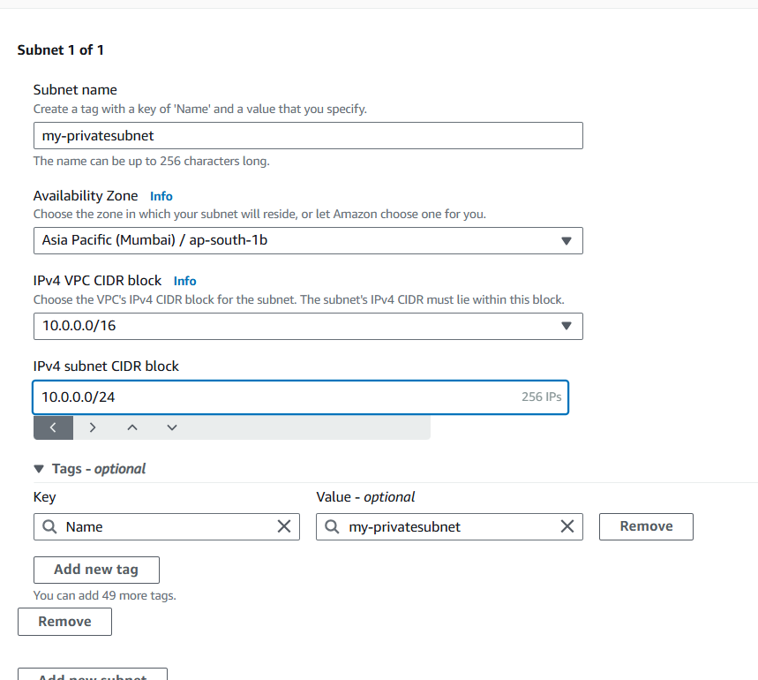

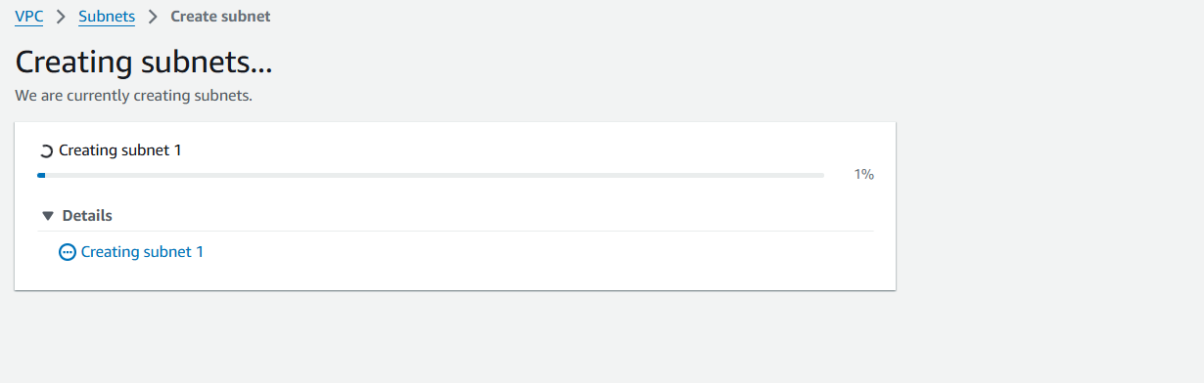

### 6. ****Connect the Internet Gateway to the Route Table****

* Select PublicRouteTable.
* Go to the **Routes** tab and click **Edit routes**.
* Add a route:
* **Destination**: 0.0.0.0/0.
* **Target**: Select the Internet Gateway (MyIGW).
* Save changes.

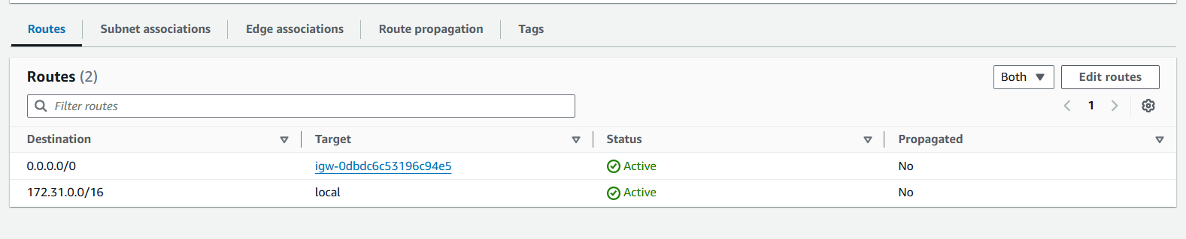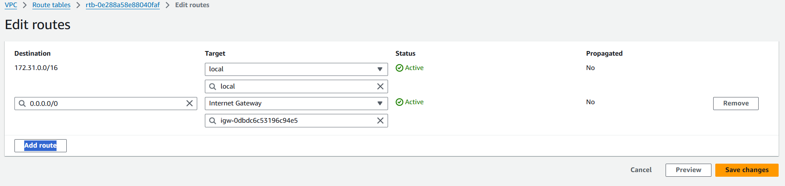

### 7. ****Associate Subnets with the Route Table****

* Select PublicRouteTable.
* Go to the **Subnet Associations** tab and click **Edit subnet associations**.
* Select PublicSubnet and save.

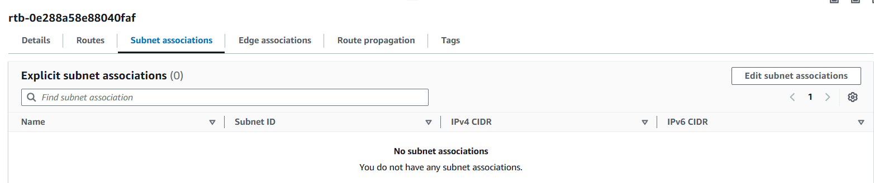

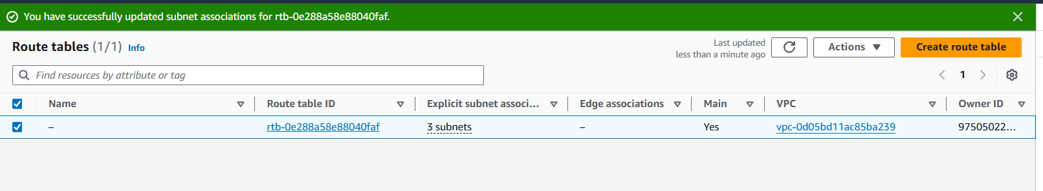

### 8. ****Launch a Linux EC2 Instance****

* Open the **EC2 Dashboard** and click **Launch Instance**.
* Configure the instance:
* **Name**: My-vm-01.
* **AMI**: Choose an Amazon Linux 2 AMI.
* **Instance type**: Select an appropriate size (e.g., t2.micro).
* **Key pair**: Select or create a new one.
* **Network settings**:
* **VPC**: Select MyVPC.
* **Subnet**: Select PublicSubnet.
* Enable **Auto-assign public IP**.
* Click **Launch Instance**.

